Jenkins CF Plugin Implementation

STEP 1: Setup the proxy settings Jenkins 🡪 manage Jenkins 🡪 manage plugins 🡪 Advanced tab

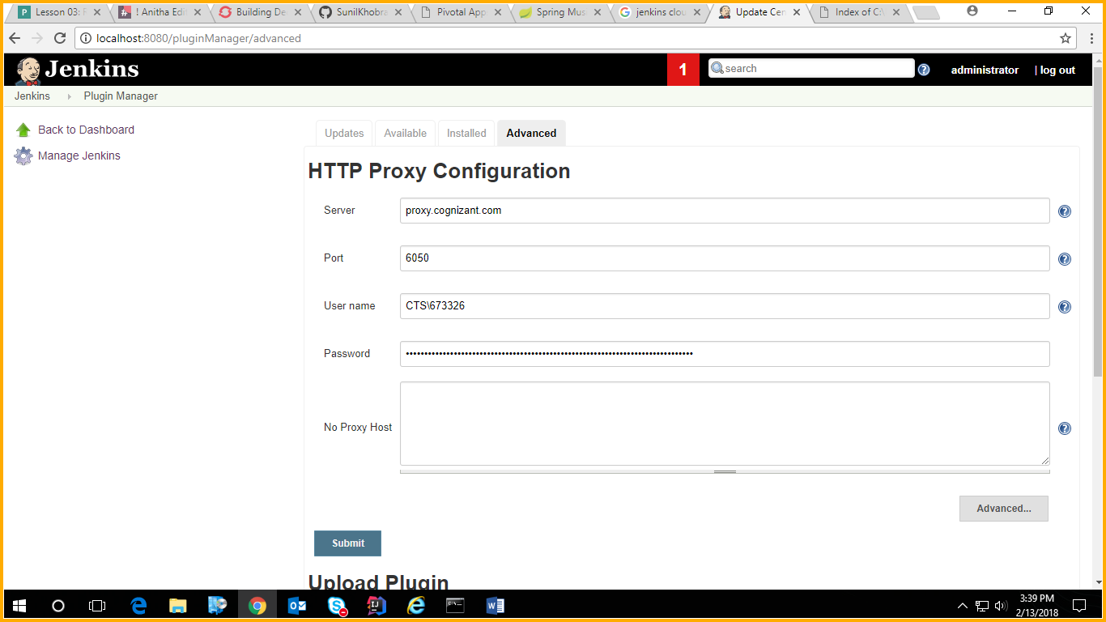

Step 2 : Download the Plugins for Cloud Foundry

1. Install all the default plugin when installing Jenkins
2. Install Cloud Foundry Plugin

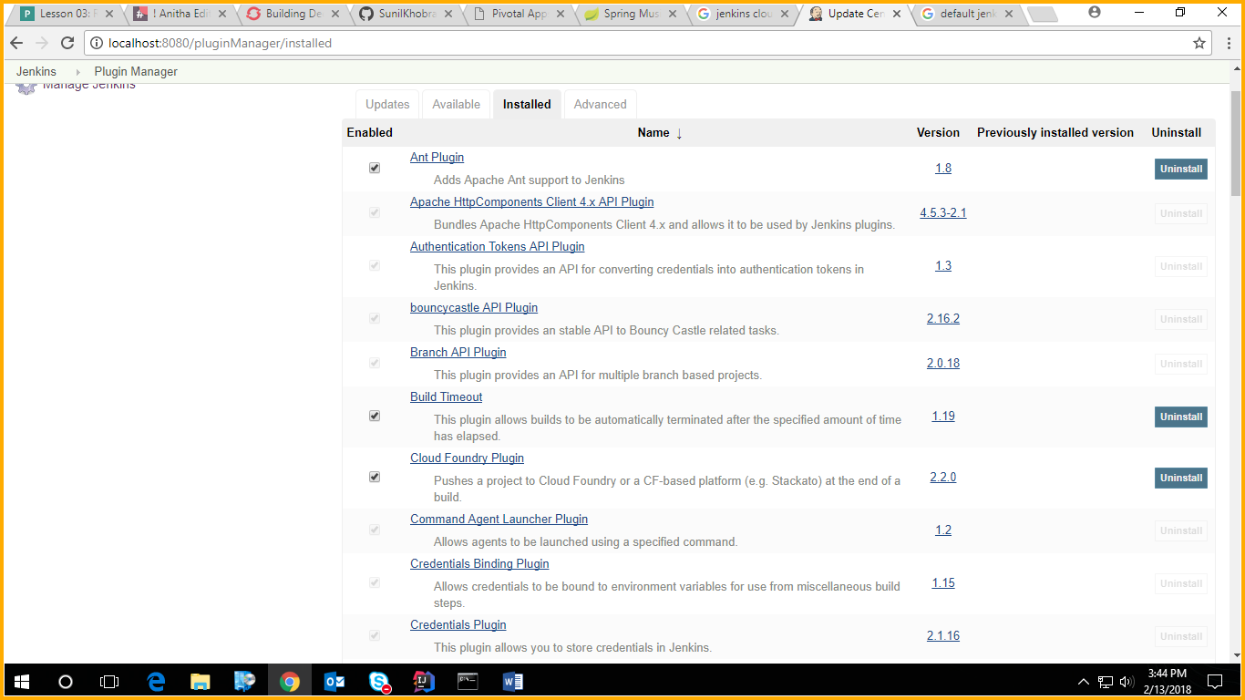

STEP 3:

Create a new Freestyle project by clicking Jenkins 🡪 New Item

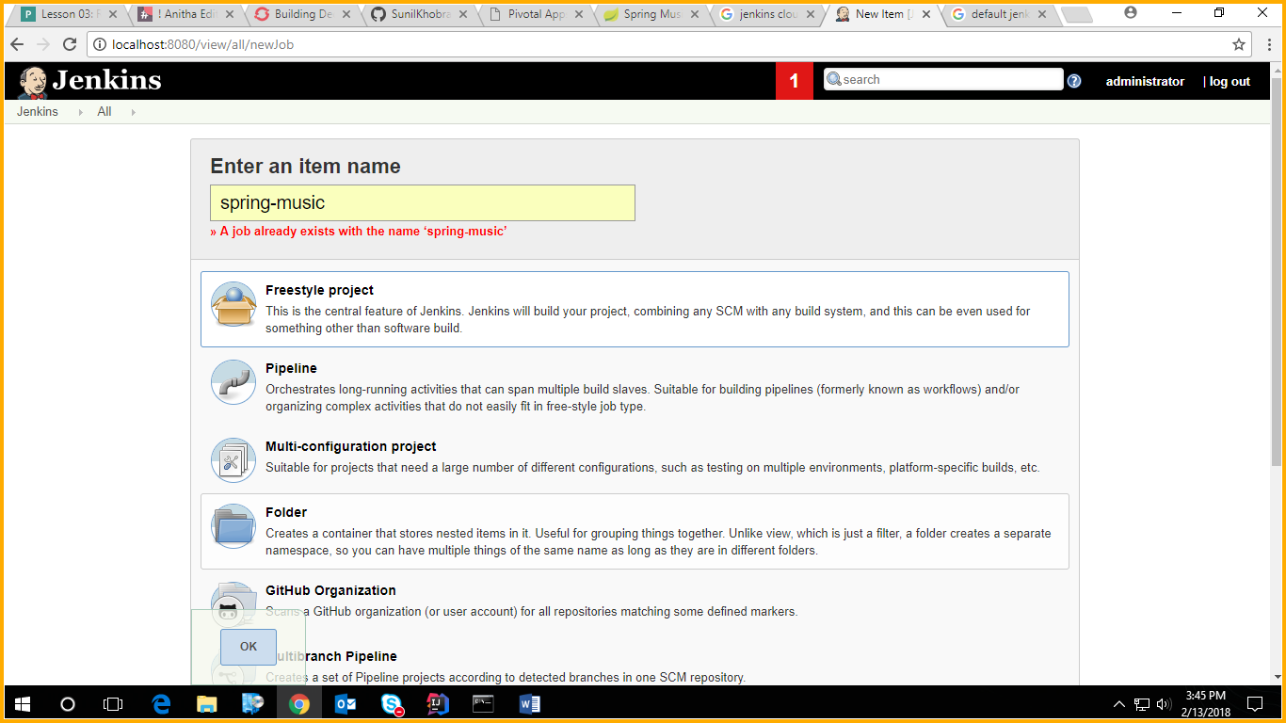

Step 4

Click the link spring-music and then configure in the navigation tab

